PROJECT REPORT ON

**EMERGENCY AMBULANCE HIRING PORTAL**

SUBMITTED BY

**Ms. Sharon Issac Daniel**

SUBMITTED TO

**SAVITRIAI PHULE PUNE UNIVERSITY**

**IN PARTIAL FULFILLMENT OF DEGREE**

**MASTER OF COMPUTER APPLICATION (SEM 1)**

UNDER THE GUIDANCE OF

**PROF.SAMIKSHA YEOLA**

Through



SADHU VASWANI INSTITUTE OF MANAGEMENT STUDIES FOR GIRLS,

KOREGOAN PARK PUNE-411001

2024-2025

**DECLARATION BY STUDENT**

TO,

The Director,

SVIMS,Koregoan Park Pune,

I undersigned hereby declare that the project titled, **“Emergency** **ambulance hiring system”** written and submitted by me to SPPPU ,Pune in partial fulfilment of the requirement of the award of the degree of **MASTER OF COMPUTER APPLICATIONS** (MCA 1) under the guidance of **MS SAMIKSHA YEOLA,** is my original work.

I further declare that to the best of my knowledge and belief, the project has not been submitted to this or any other university or institution for the award of any degree.

**Place:PUNE**

**DATE: ( Sharon Issac Daniel)**

ARCHITECTURE OF SYSTEM

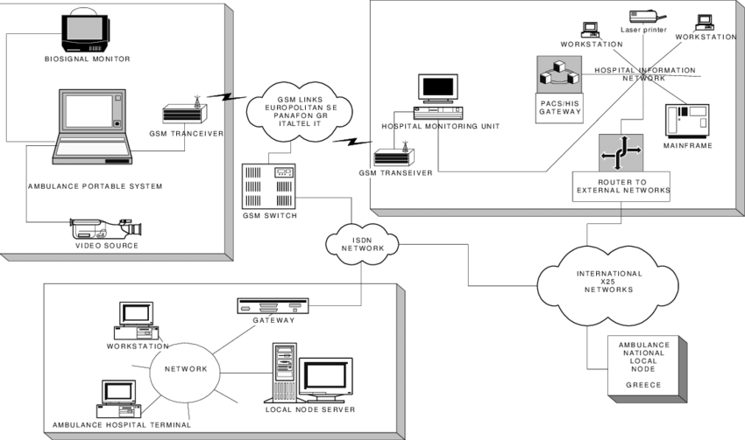

***Aknowledgment***

I extend my sincere gratitude to B H Nanwani, DR NEETA RASKAR ,DR KALPANA SALUNKHE for allowing me to carry the study and for constant encouragement ,valuable sugestions and guidance during the research work

I extend my personal gratitude to **MS SAMIKSHA YEOLA AND DR SHWETI CHANDAN** for kind cooperation and inspiration

I extend my special gratitude to my dearest family members and friends who encouraged and motivated me to complete my project report.

Place-pune

Date - (

**1.INTRODUCTION**

**1.1 Client organization Profile:**

In today’s world and in India, due to rapid growth in population and increase in traffic accidents are bound to often as the clock runs around. our goal is to design website to assist the needed patience with medical care.

**1.2 Need for system:**

The motto of the design is to bridge time line between the ambulance arrival and the call made by the patient.. Due to the heavy traffic, the ambulance driver initially had no idea of the precise location of the accident scene. As a result, we were not able to save many lives. Since everything in the world today runs on smartphones and apps, we have developed a website that allows real-timemonitoring of ambulance services.

**1.3 Scope and feasiblility of work:**

Analysis of the three services to include: assets, staffing, wage rates, collection rates and methods, billing rates, station locations-proximity to medical facilities, call volume, call response times, paramedic intercept, service levels and any other analysis that would be deemed appropriate. This data would be analyzed and recommendations for potential EMS system options within the county could be developed.

**Role of admin:**

1. Dashboard: In this section, admin can view total listed ambulance, total request received, total new request, total assign request, total on the way ambulance, total patient picked request, total patient reached and total rejected request.
2. Ambulance: In this section, admin can manage Ambulance (Add/Delete/Update).
3. Ambulance Request: In this section, admin can manage ambulance request and have right to assign ambulance and change the status according to current status.
4. Pages: In this section, admin can manage about us and contact us page of website
5. B/D Reports of Request: In this section, admin can generate request report between two dates.
6. Search Request: In this section, admin can search request details on the basis of booking number or relative number or patient name.

Admin can also update his/her change the password.

Role of user:

1.Ambulance services at any emergency costs, from any part of country

2.Visitor or Patient can visit the website and hire the ambulance.

**1.4 Operating system –H/w and S/w**

**Software specifications**

|  |  |
| --- | --- |
| **Project Name** | **Emergency Ambulance Hiring Portal Project in PHP** |
| Operating system | **Windows 7** |
| Documentation | **Microsoft office 2007or higher** |
| Browser | **Google chrome** |
| Database ,Server | **MySQL, wamp** |

**HARDWARE REQUIREMENTS**

|  |  |
| --- | --- |
| **Processor** | **Intel Pentium based sytem** |
| **Processor speed** | **250MHz to 833MHz** |
| **SYSTEM, TYPE** | **64-bit operating system, x64-based processor** |
| **DEVICE NAME** | **DESKTOP-SSQIILO** |
| **Ram speed** | **1GB** |

**1.7 Detail Description of Technology Used:**

**HTML-**

**HTML markup consists of several key components, including those called *tags* (and their *attributes*), character-based *data types*, *character references* and *entity references*. HTML tags most commonly come in pairs like <h1> and </h1>, although some represent *empty elements* and so are unpaired, for example <img>. The first tag in such a pair is the *start tag*, and the second is the *end tag* (they are also called *opening tags* and *closing tags*).**

**Another important component is the HTML**[***document type declaration***](https://en.wikipedia.org/wiki/Document_type_declaration)**, which triggers**[**standards mode**](https://en.wikipedia.org/wiki/Standards_mode)**rendering.**

**The following is an example of the classic**[**"Hello, World!" program**](https://en.wikipedia.org/wiki/%22Hello,_World!%22_program)**:**

**<!DOCTYPE html>**

**<html>**

**<head>**

**<title>This is a title</title>**

**</head>**

**<body>**

**<div>**

**<p>Hello world!</p>**

**</div>**

**</body>**

**</html>**

**ADVANTAGES OF HTML=**

* **Straightforward syntax.**
* **Compatibility with various platforms.**
* **Easy to learn and use.**

**AJAX**

**AJAX = Asynchronous JavaScript And XML.**

**AJAX is not a programming language.**

* **A browser built-in XMLHttpRequest object (to request data from a web server)**
* **JavaScript and HTML DOM (to display or use the data)**

**ADVANTAGES OF AJAX**

improved user experience, reduced bandwidth usage, and faster response times.

**JQUERY-**

* **A browser built-in XMLHttpRequest object (to request data from a web server)**
* **JavaScript and HTML DOM (to display or use the data)**
* **jQuery is a lightweight, "write less, do more", JavaScript library.**
* **The purpose of jQuery is to make it much easier to use JavaScript on your website.**
* **jQuery takes a lot of common tasks that require many lines of JavaScript code to accomplish, and wraps them into methods that you can call with a single line of code.**
* **jQuery also simplifies a lot of the complicated things from JavaScript, like AJAX calls and DOM manipulation.**

**ADVANTAGES OF JQUERY**

**JavaScript enhancement without the overhead of learning new syntax · 2. Ability to keep the code simple, clear, readable and reusable**

**JAVASCRIPT-**

**JavaScript is a programming language used for creating dynamic content on websites. It is a lightweight, cross-platform and single-threaded programming language. JavaScript is an interpreted language that executes code line by line providing more flexibility.**

* [**HTML**](https://www.geeksforgeeks.org/html-tutorial/)**adds Structure to a Webpage,**[**CSS**](https://www.geeksforgeeks.org/css-tutorial/)**styles it and JavaScript brings it to life by allowing users to interact with elements on the page, such as actions on clicking buttons, filling out forms, and showing animations.**
* **JavaScript is also used on Server side to do operations like accessing databases, file handling and security features to send response to browsers.**

**ADVANTAGES OF JAVASCRIPT**

* **Enhanced Speed and Efficiency. ...**
* **Simplified Development Process. ...**
* **Continuous Updates. ...**
* **Server Load Reduction.**

**Css**

**CSS or cascading sheet may be a text-based coding language that specifies the website formats and the way a site communicates with web browsers. The language allows web developers to regulate various style elements and functionalities, like layout, color, fonts, and therefore the formatting and display of HTML documents.**

**ADVANTAGES OF CSS**

**design language intended to simplify the process of making web pages presentable. CSS determines the visual structure, layout, and aesthetics. CSS allows you to format the design, style, font, and color of text; set margins and padding; background colors, and border styles.**

**WAMP SERVER**

**WampServer refers to a**[**solution stack**](https://en.wikipedia.org/wiki/Solution_stack)**for the**[**Microsoft Windows**](https://en.wikipedia.org/wiki/Microsoft_Windows)**operating system, created by Romain Bourdon and consisting of the**[**Apache web server**](https://en.wikipedia.org/wiki/Apache_HTTP_Server)**, [OpenSSL](https://en.wikipedia.org/wiki/OpenSSL" \o "OpenSSL) for SSL support,**[**MySQL**](https://en.wikipedia.org/wiki/MySQL)**database and**[**PHP**](https://en.wikipedia.org/wiki/PHP)**programming language**

**MY SQL**

**The acronym for**[**Structured Query Language**](https://en.wikipedia.org/wiki/Structured_Query_Language)**. A**[**relational database**](https://en.wikipedia.org/wiki/Relational_database)**organizes data into one or more data tables in which data may be related to each other; these relations help structure the data. SQL is a language that programmers use to create, modify and extract data from the relational database, as well as control user access to the database. In addition to relational databases and SQL, an RDBMS like MySQL works with an**[**operating system**](https://en.wikipedia.org/wiki/Operating_system)**to implement a relational database in a computer's storage system, manages users, allows for network access and facilitates testing database integrity and creation of backups.**

**PHP**

**PHP code is usually processed on a**[**web server**](https://en.wikipedia.org/wiki/Web_server)**by a PHP**[**interpreter**](https://en.wikipedia.org/wiki/Interpreter_(computing))**implemented as a**[**module**](https://en.wikipedia.org/wiki/Plugin_(computing))**,   a**[**Common Gateway Interface**](https://en.wikipedia.org/wiki/Common_Gateway_Interface)**(CGI) executable. On a web server, the result of the**[**interpreted**](https://en.wikipedia.org/wiki/Interpreter_(computing))**and executed PHP code—which may be any type of data, such as generated**[**HTML**](https://en.wikipedia.org/wiki/HTML)**or**[**binary**](https://en.wikipedia.org/wiki/Binary_number)**image data—would form the whole or part of an**[**HTTP**](https://en.wikipedia.org/wiki/HTTP)**response. Various**[**web template systems**](https://en.wikipedia.org/wiki/Web_template_system)**, web**[**content management systems**](https://en.wikipedia.org/wiki/Content_management_system)**, and**[**web frameworks**](https://en.wikipedia.org/wiki/Web_framework)

**CHAPTER2 : PROPOSED SYSTEM**

**The proposed system presents the design of a surveillance system for emergency patient transport. India has the highest number of road accidents in the world, so this system will help you monitor the location of ambulances using Google Maps and GPS. To prevent this, it is possible to provide medical facilities to accident victims in a short time with the help of advanced wireless GPStechnology. Continuous monitoring of ambulance location and patient condition during critical times of patient transport can help improve medical care. One of the problems in patient transport is transportation related issues. Therefore, high-speed, economical and efficient traffic control is required. You can view the location of the ambulance and the patient's heart rate and temperature status.**

**2.1 OBJECTIVES OF SYSTEM**

**1.  To provide First aid to preserve life, prevent further injury & promote recovery.  
2.   To provide comprehensive 24X7 hours emergency response services by direct calling 108 Toll free number from any network in Maharashtra.  
3.   System to leverage all the stake holders to offer comprehensive range of services in emergencies.  
4.   Expected 20% reduction in mortality & reduce morbidity.**

**2.3 USER REQUIREMENTS**

**USERS CAN HAVE ACCES TO**

* **Central Control Room/Emergency Response Centre (ERC) is established at Chest Hospital, Aundh, Pune.**
* **Real time location of ambulances using GPS-GPRS technology is being monitored from call center.**
* **24X7 trained Call takers & call dispatchers are available for emergency response.**
* **Daily, weekly & monthly MIS reports can be generated from call center.**
* **There are total 60 call assistants deployed per shift at ERC, Pune.**

**CHAPTER 3: Analysis and design**

2 Level DFD diagram 2.0

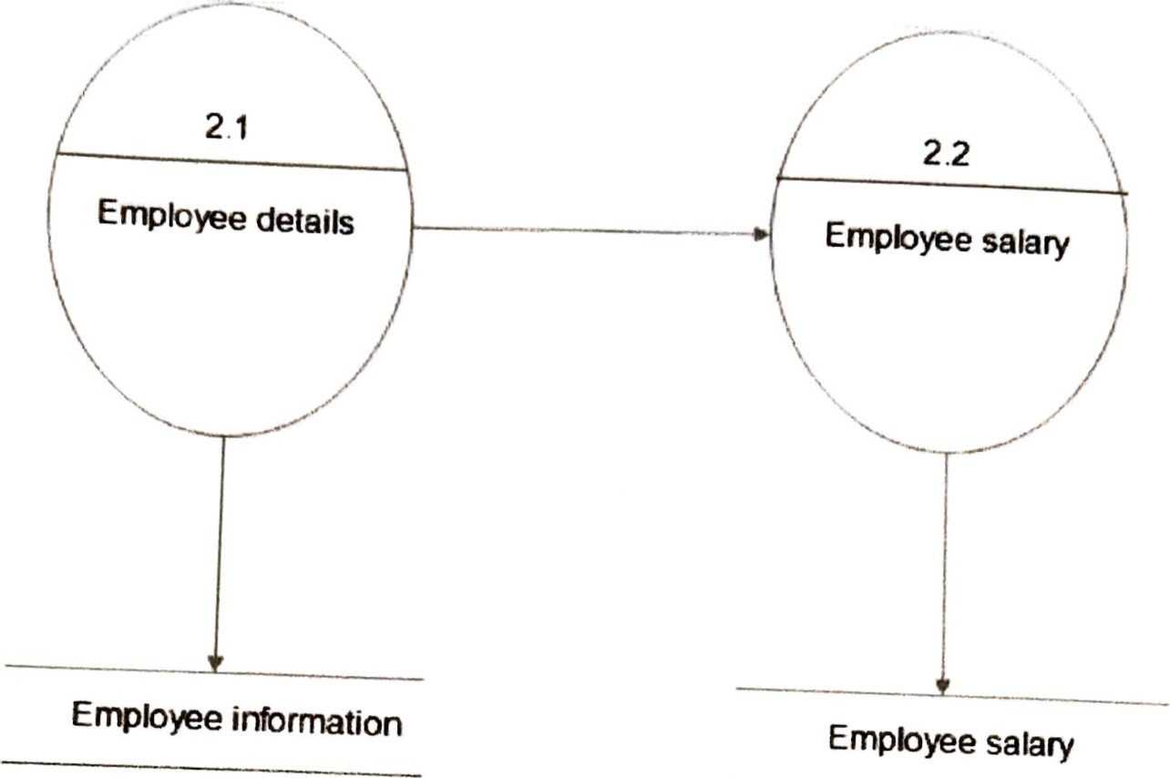

Admin salary

Admin info

PATIENT

admin

**3.2 TABLE SPECIFICATIONS**

patient

|  |  |  |  |  |  |  |
| --- | --- | --- | --- | --- | --- | --- |
| Table Name |  | PATIENT | | | |  |
| Primary Key |  |  | | | |
| Foreign key |  |  | | | |
| Description of Table |  | Registration details of the PATIENT is going to be stored in this table. | | | |
| Sr. no. |  | Field Name | Data type with size | Constraint | Description |
| 1 |  |  | int (5) | Auto  Increment | To store id of user |
| 2 |  | P regdate | date | Not Null | To store the date of the patient registration |
| 3 |  | p name | varchar  (50) | Not Null | To store the name of patient |
| 4 |  | p mobile | int (13) | Not Null | To store mobile number of patient |
| 5 |  | email id | varchar (50) | Not Null | To store the email address of the patient |  |
| 6 |  | p age | int (2) | Not Null | To store the age of the patient |  |
| 7 |  | p address | varchar (100) | Not Null | To store the address of the patient | |
| 8 |  | P password | varchar (8) | Not null | To store the password of the patient | |

24

|  |  |  |  |  |  |  |  |  |  |  |  |  |  |  |  |  |  |  |  |  |  |  |  |  |  |  |  |  |  |  |  |  |  |  |  |  |  |  |  |  |  |  |  |  |  |  |  |  |  |  |  |  |  |  |  |  |  |  |  |  |  |  |  |  |  |  |  |  |  |  |  |  |  |  |  |  |  |  |  |  |  |  |  |  |  |  |  |  |  |  |  |  |  |  |  |  |  |  |  |  |  |  |  |  |  |  |  |  |  |  |  |  |  |  |  |  |  |  |  |  |  |  |  |  |  |  |  |  |  |  |  |  |  |  |  |  |  |  |  |  |  |  |
| --- | --- | --- | --- | --- | --- | --- | --- | --- | --- | --- | --- | --- | --- | --- | --- | --- | --- | --- | --- | --- | --- | --- | --- | --- | --- | --- | --- | --- | --- | --- | --- | --- | --- | --- | --- | --- | --- | --- | --- | --- | --- | --- | --- | --- | --- | --- | --- | --- | --- | --- | --- | --- | --- | --- | --- | --- | --- | --- | --- | --- | --- | --- | --- | --- | --- | --- | --- | --- | --- | --- | --- | --- | --- | --- | --- | --- | --- | --- | --- | --- | --- | --- | --- | --- | --- | --- | --- | --- | --- | --- | --- | --- | --- | --- | --- | --- | --- | --- | --- | --- | --- | --- | --- | --- | --- | --- | --- | --- | --- | --- | --- | --- | --- | --- | --- | --- | --- | --- | --- | --- | --- | --- | --- | --- | --- | --- | --- | --- | --- | --- | --- | --- | --- | --- | --- | --- | --- | --- | --- | --- | --- | --- |
|  |  | ambulance   |  |  |  |  |  |  |  |  |  |  |  |  | | --- | --- | --- | --- | --- | --- | --- | --- | --- | --- | --- | --- | | Table Name |  | AMBULANCE SERVICE | | | | | | | |  |  | | Primary Key |  |  | | | | | | | | | Foreign key |  |  | | | | | | | | | Description of Table |  | Details of available ambulance are going to be stored in this table. | | | | | | | | | Sr. no. |  | Field Name | | Data type with size | | Constraint | | Description | | | 1 |  | A id | | int (5) | | Auto  Increment | | To store id of ambulance | | | 3 |  | A name | | varchar (50) | | Not Null | | To store the name of ambulance | | | 4 |  | address | | varchar (100) | | Not Null | | To store the address of the hospital | | | | 5 |  | A description | | varchar (50) | | Not Null | | To store the description of the ambulance | | | | 6 |  | A_cost | | int (4) | | Not Null | | To store the cost of the service | | | | 7 |  | A_company | | int (10) | | Not Null | | | To store the quantity of the veehicle | | | 8 |  | | A category | varchar (50) | | | Null | | To store the  ventilator | |  | | 9 |  | | A service |  | null | | Not Null | | To store the image of ambulance | | |   25 |

26

**3.3 ERD**

**3.4 class diagram**

EQUIPPED

V_ID

TOOL_ID

Ambulance

A_id

A_COMPANY

patient

P_name

Dob

Critical stage

**\***

Staff

S_ID

SHIFT_ID

ADMIN

A_name

A_WORK

A_stafff

HOSPITAL

H_ID

H_name

H_address

CARRIES

NAME

LOCATION

AMOUNT

STATUS

START-_READING

P_id

V_id

P_ID

v

**3.5 USE CASE DIAGRAM**

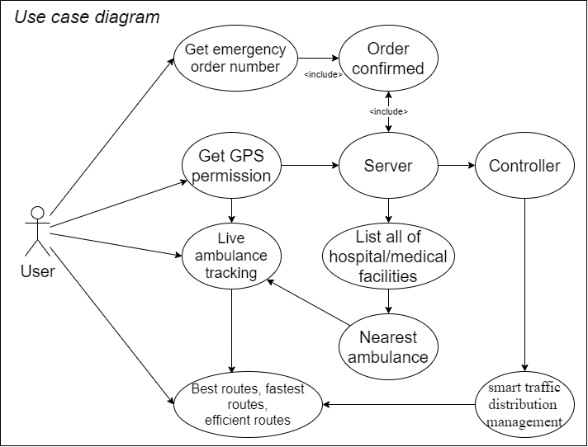

**3.7 ACTIVITY DIAGRAM**

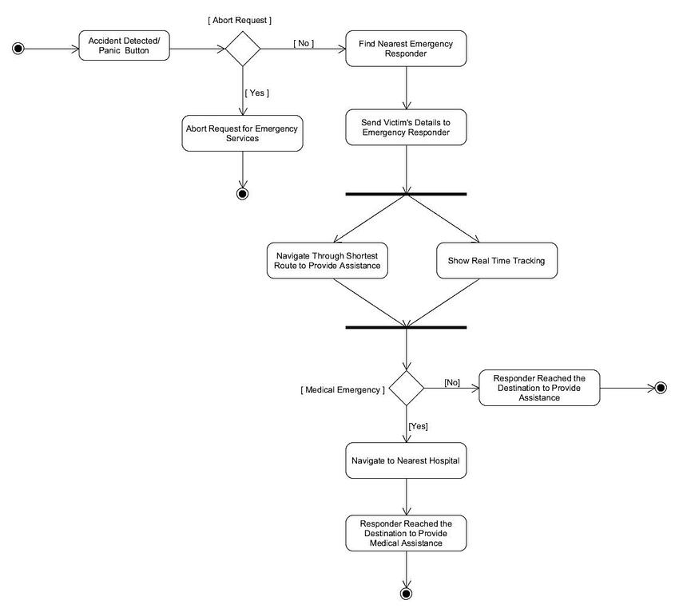

**Chapter 4 USER MANUAL**

**4.1 SCREENS**

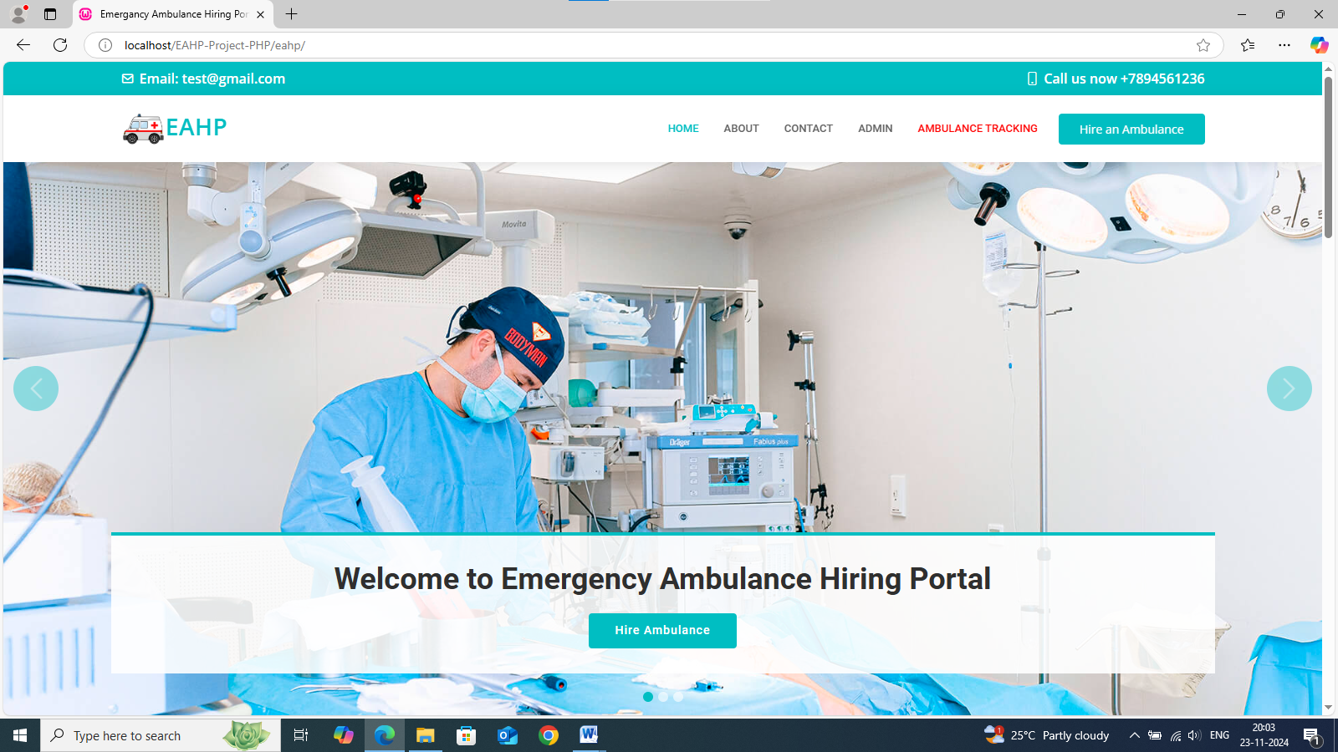

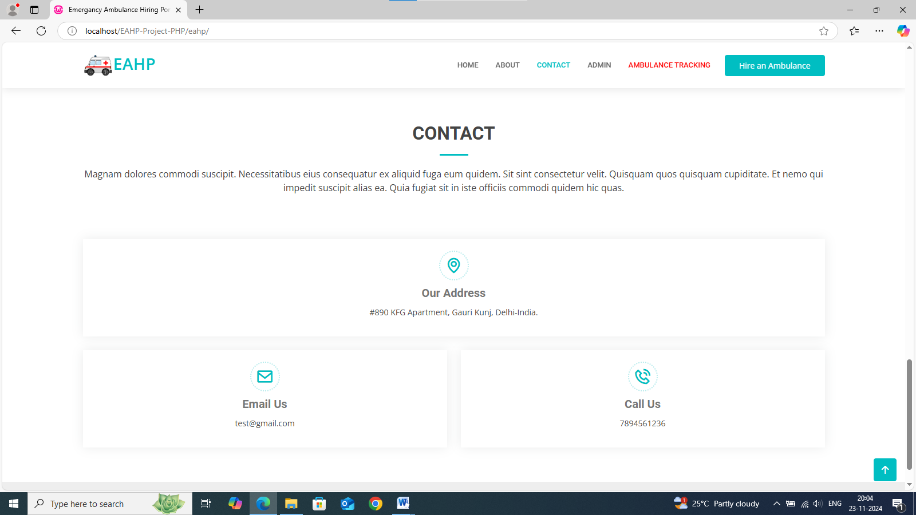

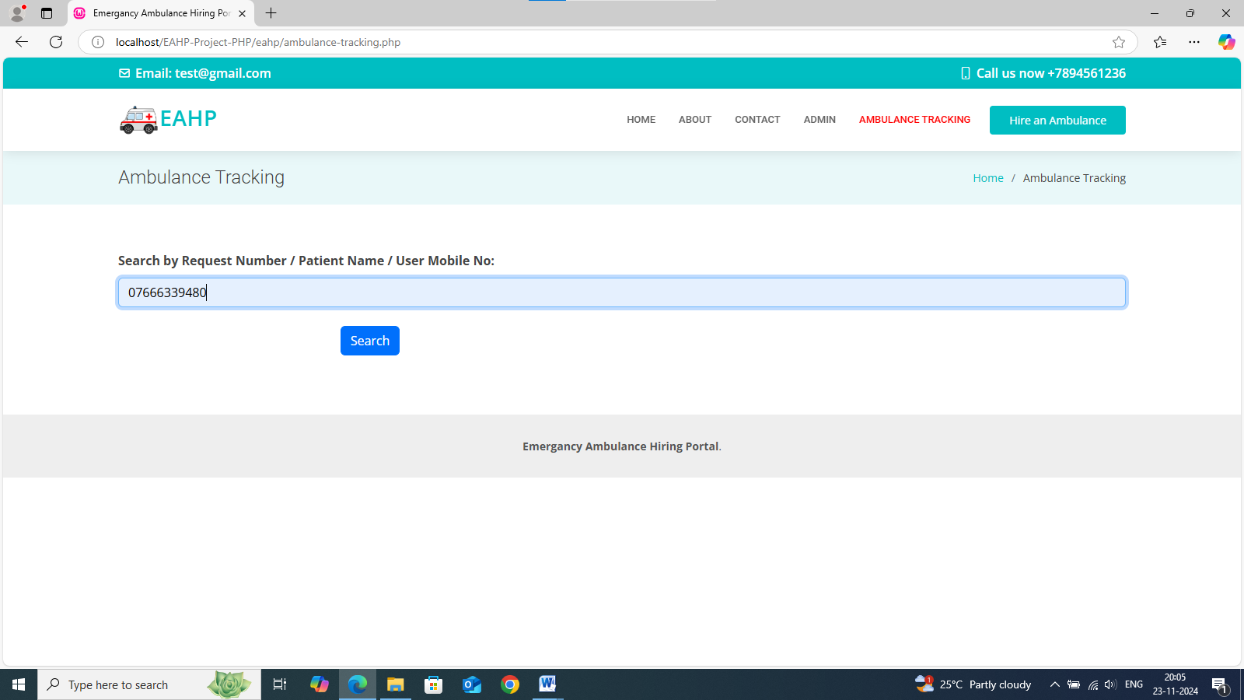

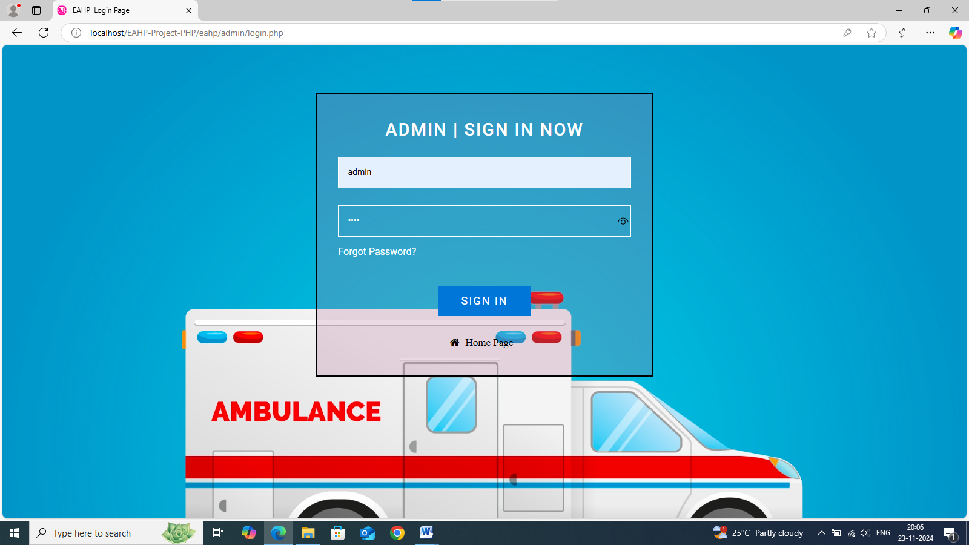

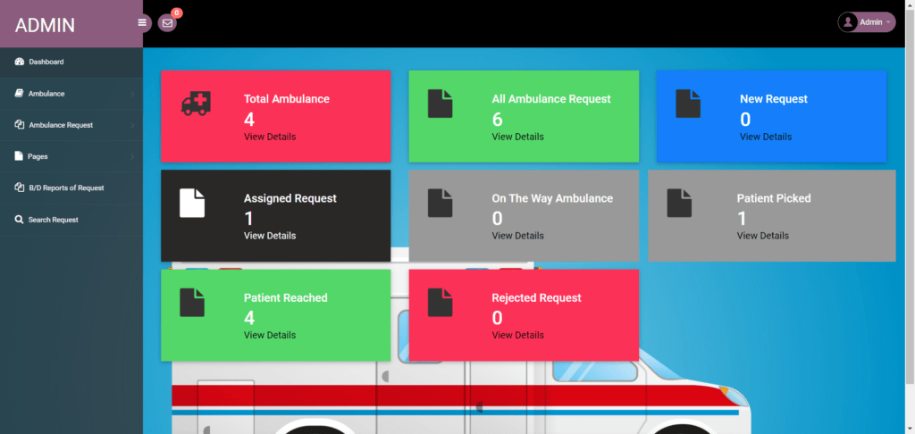

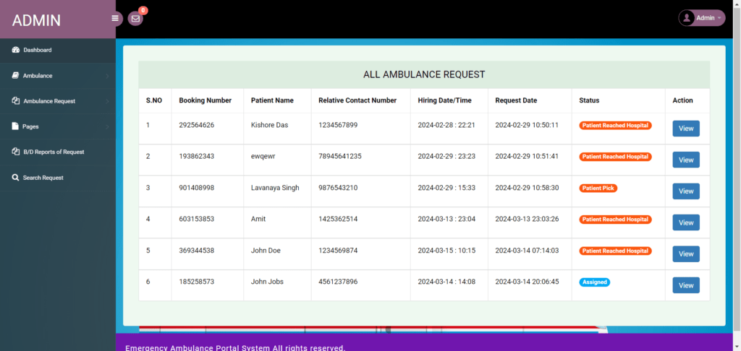

**4.2 Limitations**

1. **Traffic Congestion: Ambulance services often struggle with significant delays due to heavy traffic, particularly in urban areas, which can critically impact response times and patient outcomes.**
2. **Limited Funding: Inadequate financial resources restrict the ability to acquire advanced medical equipment, maintain vehicles, and provide comprehensive staff training, ultimately affecting service quality.**
3. **Staff Shortages: A shortage of qualified emergency**[**medical**](https://www.goaid.in/10-reasons-to-choose-goaid-ambulance-for-your-medical-transport-2/)**technicians (EMTs) and paramedics leads to increased workloads, fatigue, and potentially reduced effectiveness in emergency response.**
4. **Equipment Malfunctions: The use of outdated or malfunctioning medical equipment can compromise the quality of patient care and pose significant risks during emergency medical interventions.**
5. **Geographical Barriers: Ambulance services in rural or remote regions face challenges in reaching patients quickly due to long distances, difficult terrain, and limited infrastructure.**
6. **Communication Issues: Inefficient or unreliable communication systems can hinder coordination between ambulance crews, dispatch centers, and hospitals, delaying critical care.**
7. **High Call Volumes: An overwhelming number of emergency calls can strain resources, leading to longer response times and potentially impacting patient care quality.**

**4.3 Future Enhancement**

Automated and Autonomous Ambulances: Research and development are ongoing in the field of automated and autonomous ambulances. These vehicles have the potential to further reduce response times and improve patient outcomes by utilizing advanced navigation and robotics

BIBLIOGRAPHY ( SAMPLE PROGRAM CODE)

**Sample program code**

**SET SQL_MODE = "NO_AUTO_VALUE_ON_ZERO";**

**START TRANSACTION;**

**SET time_zone = "+00:00";**

**/*!40101 SET @OLD_CHARACTER_SET_CLIENT=@@CHARACTER_SET_CLIENT */;**

**/*!40101 SET @OLD_CHARACTER_SET_RESULTS=@@CHARACTER_SET_RESULTS */;**

**/*!40101 SET @OLD_COLLATION_CONNECTION=@@COLLATION_CONNECTION */;**

**/*!40101 SET NAMES utf8mb4 */;**

**--**

**-- Database: `eahpdb`**

**--**

**-- --------------------------------------------------------**

**--**

**-- Table structure for table `tbladmin`**

**--**

**CREATE TABLE `tbladmin` (**

**`ID` int(10) NOT NULL,**

**`AdminName` varchar(120) DEFAULT NULL,**

**`UserName` varchar(120) DEFAULT NULL,**

**`MobileNumber` bigint(10) DEFAULT NULL,**

**`Email` varchar(120) DEFAULT NULL,**

**`Password` varchar(120) DEFAULT NULL,**

**`AdminRegdate` timestamp NULL DEFAULT current_timestamp()**

**) ENGINE=InnoDB DEFAULT CHARSET=latin1 COLLATE=latin1_swedish_ci;**

**--**

**-- Dumping data for table `tbladmin`**

**--**

**INSERT INTO `tbladmin` (`ID`, `AdminName`, `UserName`, `MobileNumber`, `Email`, `Password`, `AdminRegdate`) VALUES**

**(1, 'Admin', 'admin', 8989898980, 'admin@gmail.com', 'f925916e2754e5e03f75dd58a5733251', '2024-01-10 08:56:46');**

**-- --------------------------------------------------------**

**--**

**-- Table structure for table `tblambulance`**

**--**

**CREATE TABLE `tblambulance` (**

**`ID` int(11) NOT NULL,**

**`AmbulanceType` varchar(250) DEFAULT NULL,**

**`AmbRegNum` varchar(250) DEFAULT NULL,**

**`DriverName` varchar(250) DEFAULT NULL,**

**`DriverContactNumber` bigint(20) DEFAULT NULL,**

**`CreationDate` timestamp NULL DEFAULT current_timestamp(),**

**`Status` varchar(250) DEFAULT NULL,**

**`UpdationDate` timestamp NULL DEFAULT NULL ON UPDATE current_timestamp()**

**) ENGINE=InnoDB DEFAULT CHARSET=utf8mb4 COLLATE=utf8mb4_general_ci;**

**--**

**-- Dumping data for table `tblambulance`**

**--**

**INSERT INTO `tblambulance` (`ID`, `AmbulanceType`, `AmbRegNum`, `DriverName`, `DriverContactNumber`, `CreationDate`, `Status`, `UpdationDate`) VALUES**

**(1, '1', 'DL14RT5678', 'Joginder Singh', 4567891236, '2024-03-03 06:00:22', 'Pickup', '2024-03-14 14:51:24'),**

**(2, '2', 'DL15RT5678', 'kamal Yadav', 7894563219, '2024-03-03 06:02:06', 'Assigned', '2024-03-14 14:39:45'),**

**(3, '1', 'DL14RT5678', 'Ramesh Singh', 2567891231, '2024-03-03 06:00:22', 'Pickup', '2024-03-14 14:51:24'),**

**(4, '2', 'UP15RT5612', 'Toshib Yadav', 6894563219, '2024-03-03 06:02:06', NULL, NULL);**

**-- --------------------------------------------------------**

**--**

**-- Table structure for table `tblambulancehiring`**

**--**

**CREATE TABLE `tblambulancehiring` (**

**`ID` int(11) NOT NULL,**

**`BookingNumber` int(10) DEFAULT NULL,**

**`PatientName` varchar(250) DEFAULT NULL,**

**`RelativeName` varchar(250) DEFAULT NULL,**

**`RelativeConNum` bigint(11) DEFAULT NULL,**

**`HiringDate` varchar(250) DEFAULT NULL,**

**`HiringTime` varchar(250) DEFAULT NULL,**

**`AmbulanceType` int(5) DEFAULT NULL,**

**`Address` mediumtext DEFAULT NULL,**

**`City` mediumtext DEFAULT NULL,**

**`State` mediumtext DEFAULT NULL,**

**`Message` longtext DEFAULT NULL,**

**`BookingDate` timestamp NULL DEFAULT current_timestamp(),**

**`Remark` varchar(250) DEFAULT NULL,**

**`Status` varchar(250) DEFAULT NULL,**

**`AmbulanceRegNo` varchar(250) DEFAULT NULL,**

**`UpdationDate` timestamp NULL DEFAULT NULL ON UPDATE current_timestamp()**

**) ENGINE=InnoDB DEFAULT CHARSET=utf8mb4 COLLATE=utf8mb4_general_ci;**

**--**